

**UNIVERSITI TEKNOLOGI MARA**

**FACULTY OF COMPUTER AND MATHEMATICAL SCIENCES**

**BACHELOR OF INFORMATION TECHNOLOGY (HONS.)**

**CSC444**

|  |
| --- |
| **JAVA PROGRAMMING** |

**PROJECT 1**

**(INVENTORY MANAGEMENT SYSTEM)**

**­­**

|  |
| --- |
| **PREPARED FOR:**  MUHAMMAD NABIL FIKRI BIN JAMALUDDIN |

**GROUP BY:** RCS2405A

**DATE OF SUBMISSION:** 24 April, 2019

**PREPARED BY:**

|  |  |
| --- | --- |
| MOHD FAHMY IZWAN BIN ZULKHAFRI | 2016758447 |
| AMRULLAH BIN ABDUL RAHMAN | 2016552759 |

TABLE OF CONTENTS

TABLE OF CONTENTS 2

1.0 introduction 4

2.0 FLOW CHART 5

2.1 Staff 5

2.2 Admin 7

3.0 SAMPLE INPUT AND OUTPUT 9

3.1 Login 9

3.2 Admin Menu 11

3.3 Admin: Employee Interface 11

3.3.1 Register Employee 12

3.3.2 Update Employee 13

3.3.3 Delete Employee 14

3.4 Admin: Stationaries Interface 14

3.4.1 Register Stationaries 15

3.4.2 Update Stationaries 15

3.4.3 Delete Stationaries 16

3.5 Admin : Furniture Interface 17

3.5.1 Register Furniture 17

3.5.2 Update Furniture 17

3.5.3 Delete Furniture 18

3.6 Admin : Devices Interface 18

3.6.1 Register Devices 18

3.6.2 Update Devices 19

3.6.3 Delete Devices 19

3.7 Admin : Request list interface 20

3.8 Admin : View report 21

3.9 General Error Interface 22

3.9.1 Add Error Message 22

3.9.2 Update Error Message 22

3.9.3 Delete Error Message 23

3.10 Staff: Stationaries Interface 23

3.10.1 Request Stationaries 24

3.11 Staff: Furniture Interface 26

3.12 Staff: Device Interface 27

3.13 Staff: List Request Interface 28

4.0 RESULT 29

5.0 CONCLUSION 30

# 1.0 introduction

**1.1 About Project**

This project about Amaz Company to manage office inventory. So we need to create a new system that can help to organize and manage office inventory in our company to manage and track inventories of office such as stationaries like papers, pencil, markers, and others. We also need to manage and track furniture such as chair, desk, whiteboard, and others and electronic devices such as computer, printers, projector and others because the current method we use are done by manually to record so we face many problems.

**1.2 Problems of existing/conventional system**

Manual records of inventory have led to many missed opportunities for these items because currently record all item detail such as name, category, product code, date, status are done manually in book, so people do not know the status of the item if it can be used or not because not all item can be used at any time. Manual records will also cause management to become irregular and cause waste time to identify about the item.

**1.3 Determination made by company**

After we are analysing the current method, we decide to create a program that can be able to manage and track inventories of office. The program will involve between admin and staff where they need to login into program to keep safe and we must do improvement as allowing people to know current status about item whether it can be used or not in order to ensure process of request to become more systematic and organized. In order to keep track of the item from missing all the item must be registered to know that person who in charge on it.

# 2.0 FLOW CHART

## 2.1 Staff

Figure 2.1 Staff flow chart

Base on flow chart above as can see in Figure 2.1, Firstly, Staff will need to login they Id and password to authorize from data. If authentication is invalid the system will be back to login interface so staff need to insert the correct id or password again and if authentication is valid the system will proceed to view list inventory. Next, staff can select item to choose which want they want to know the detail of item and then they can know the status of the item whether it is in use, in store or disposed. After that, if staff want to make request they need to insert they information then the item status will update otherwise if no they can view back list inventory. The request will pending until admin approve the item request.

## 2.2 Admin

Figure 2.2 Admin flow chart

Base on Admin flow chart as show in Figure 2.2. Firstly, admin need to login the username and password to authorize from data. If authentication is invalid the system will be show back to login interface so admin need to insert again the correct username and password and if authentication is valid the system will proceed to admin menu interface where admin can choose either to proceed with manage staff, manage inventories, view request list, and view report. If admin decide to manage staff they can register, update and delete staff. In manage inventories admin also can register, update and delete inventories and for view request list admin can see request from all inventories that come from staff. Lastly, for view report if yes admin can see display statistical report from the system and if no the system will be end the system.

# 3.0 SAMPLE INPUT AND OUTPUT

## 3.1 Login

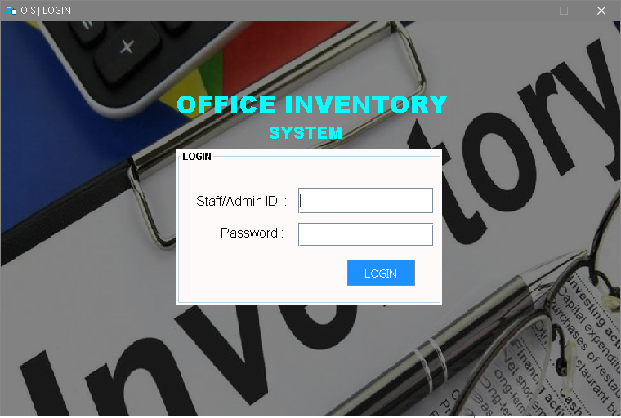

Admin and staff will need to insert they username and Password for login the system

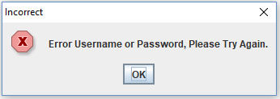

If user insert wrong username or password the error message will pop out.

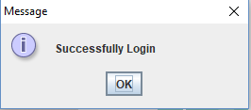

If user insert corrent username and password the success message will pop out.

## Admin Menu

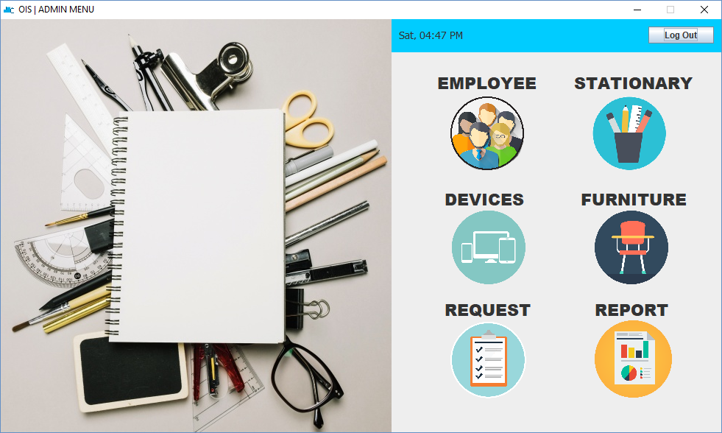This is for admin menu. Admin have 6 option to choose, the first one is to register employee, second is register stationary, third is register devices, fourth is register furniture, next button for view request and lastly view report for all inventory.

## Admin: Employee Interface

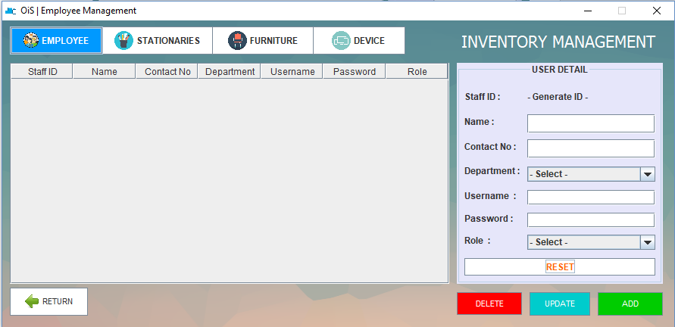

This is interface for admin that can add, update, delete and add employee and view all employee detail in table.

### Register Employee

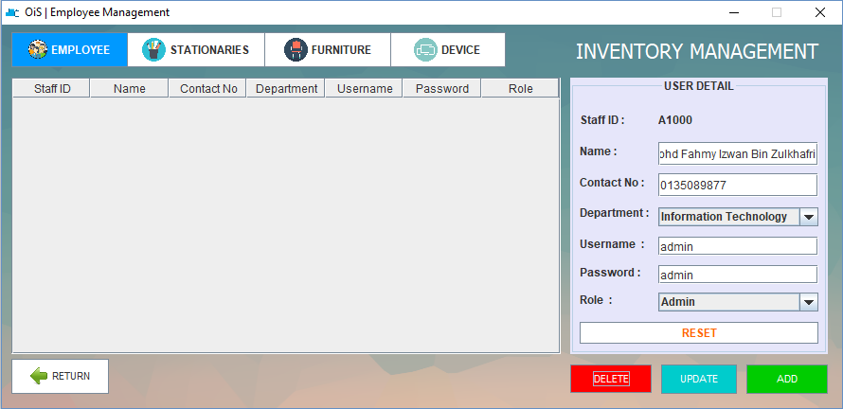

At right side, admin can register employee detail like name, contact, department, username, password and role by click on green button.

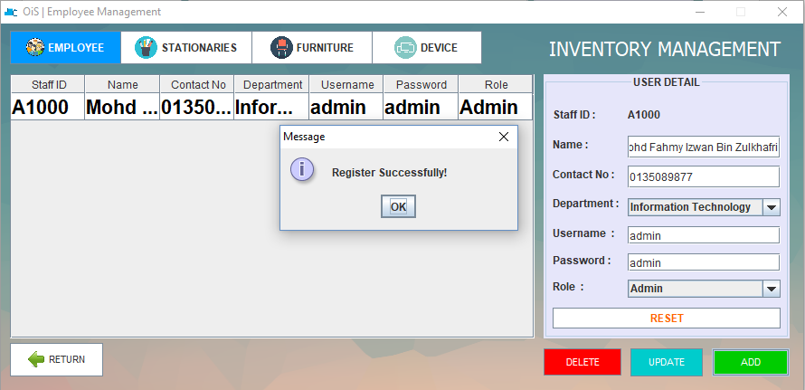

After add employee detail the information will pop out the message after successful add employee and then it will show in table

### Update Employee

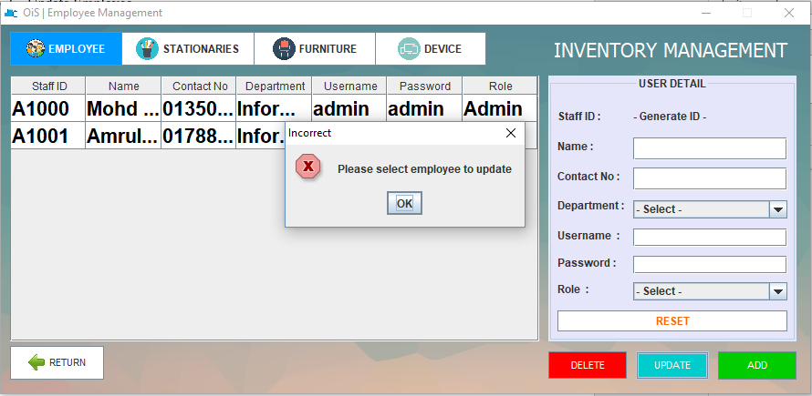

User need to select table which employee before they want to update because the error message will pop out if not select any employee detail from table at left side.

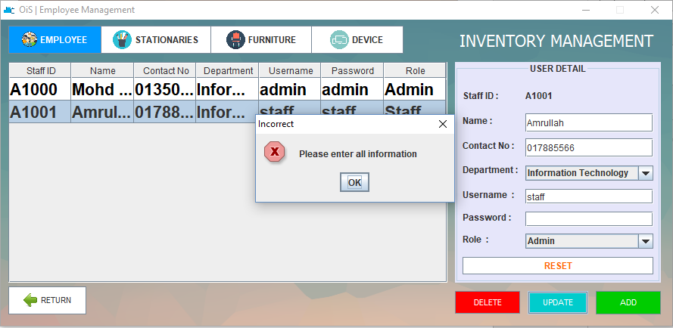

If user left empty place in any information of employee, the error message will pop out to remind user to enter all information.

### Delete Employee

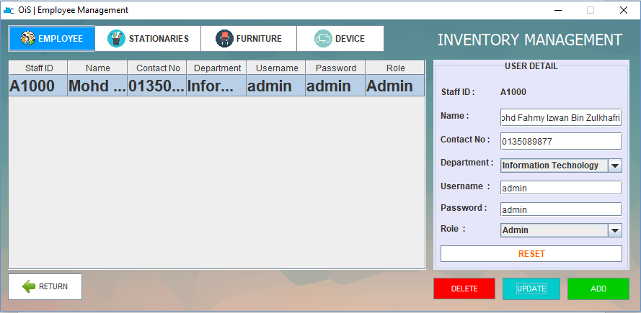

For delete employee detail user need to select from list on the table and then click delete button to delete employee.

## Admin: Stationaries Interface

## 

This is interface for admin that can add, update, delete and add stationaries and view all stationaries detail in table.

### Register Stationaries

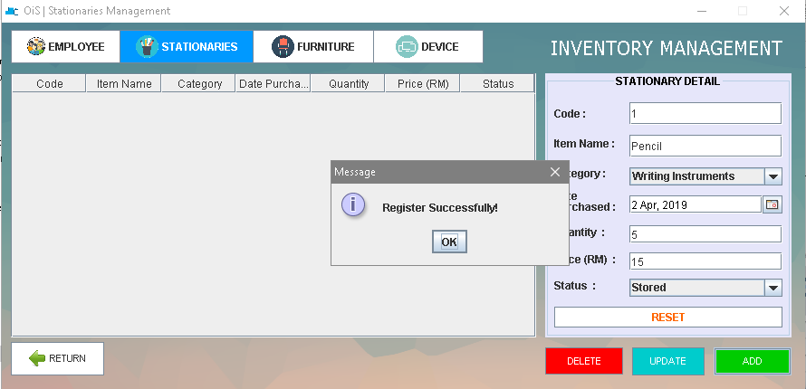

At right side, admin can register stationaries detail like code, item name, category, date purchased, quantity, price and status. After add stationary detail the information will pop out the message after successful add stationary and then it will show in table.

### Update Stationaries

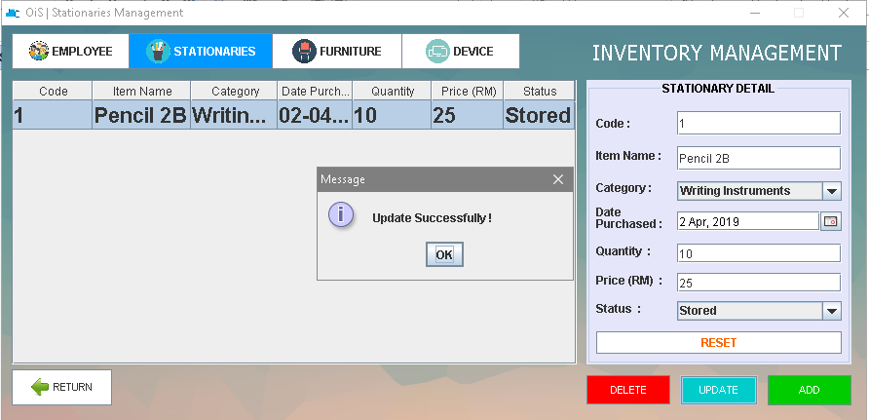

For update, admin need to select from table to update stationary detail. After that, the successful message will pop out.

### Delete Stationaries

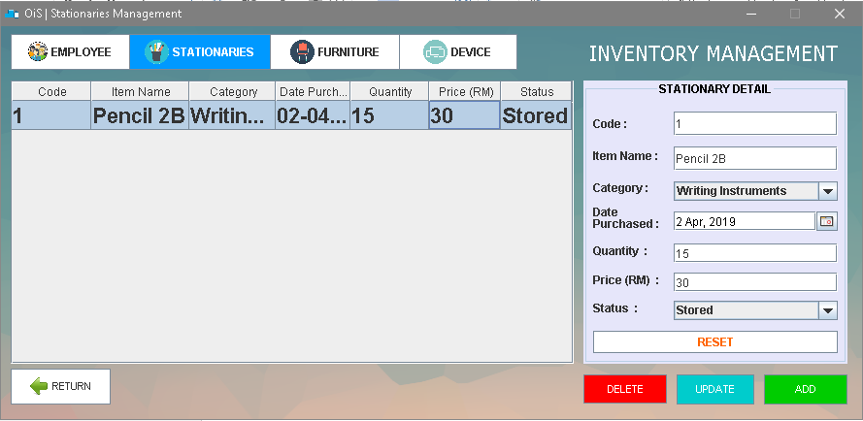

For delete stationary detail user need to select from list on the table and then click delete button with red colour to delete stationary.

## 3.5 Admin: Furniture Interface

### Register Furniture

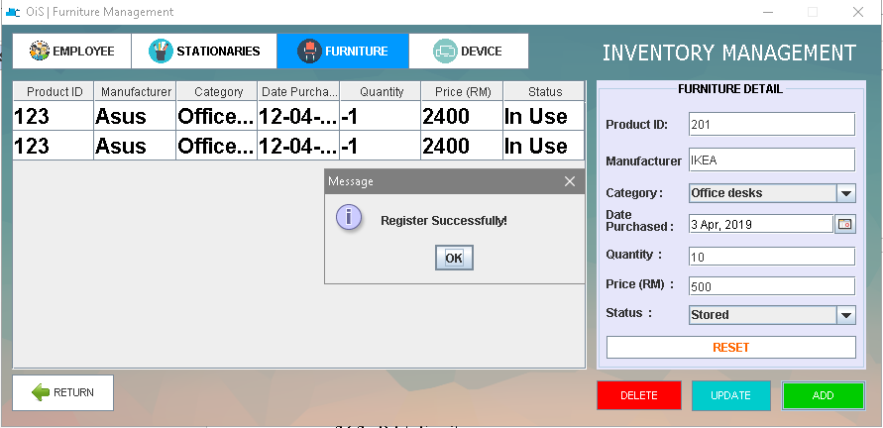

Admin can register furniture detail such as product Id, manufacturer, category, date purchased, quantity, price and status. After add furniture detail the information will pop out the message after successful add furniture and then it will show in table.

### Update Furniture

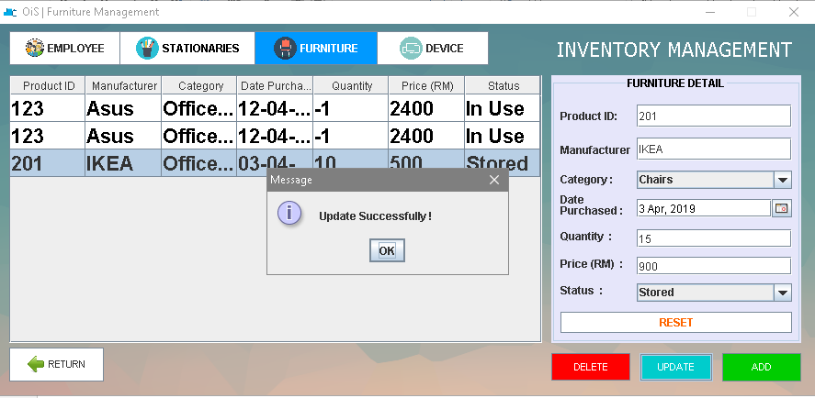

For update furniture detail, admin need to select from table. After that, the successful message will pop out.

### Delete Furniture

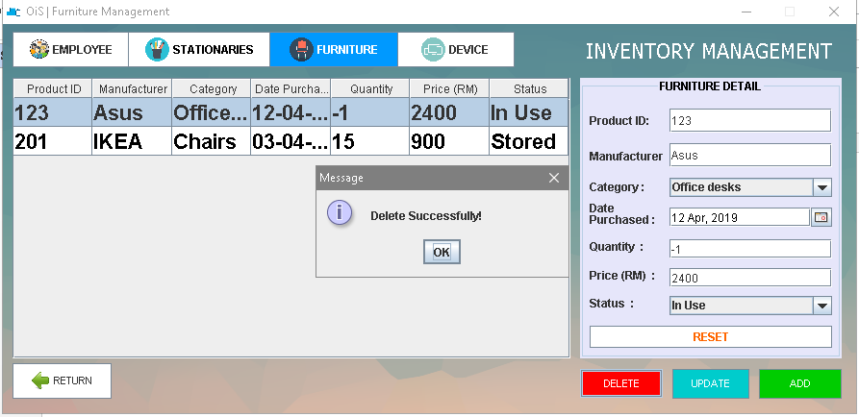

For delete furniture user need to select from list on the table and then click delete button with red colour to delete furniture. After that, the successful message will pop out.

## Admin: Devices Interface

### Register Devices

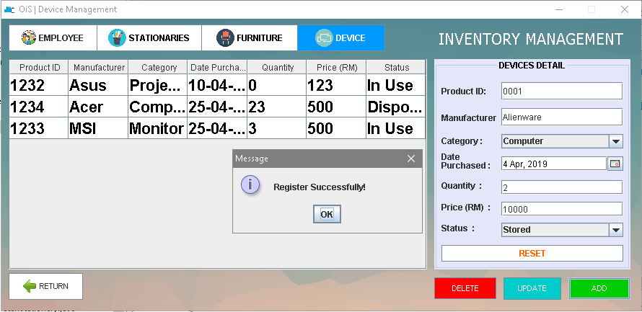

In Device, admin can register device detail such as product Id, manufacturer, category, date purchased, quantity, price and status. After click on add button, device detail the successful message will pop out and then it will show in table.

### Update Devices

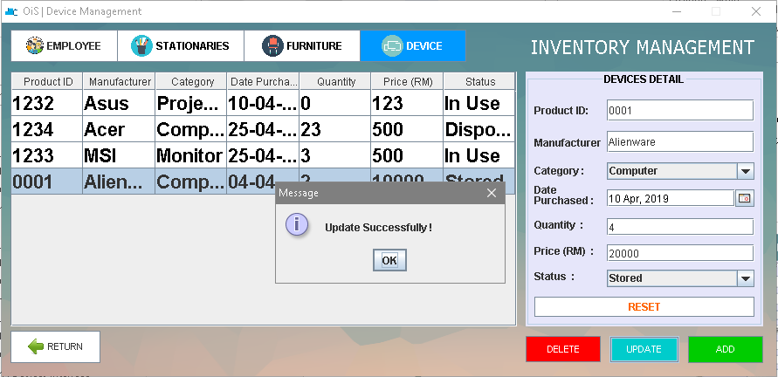

For update device detail, admin need to select from table. After that, the successful message will pop out.

### Delete Devices

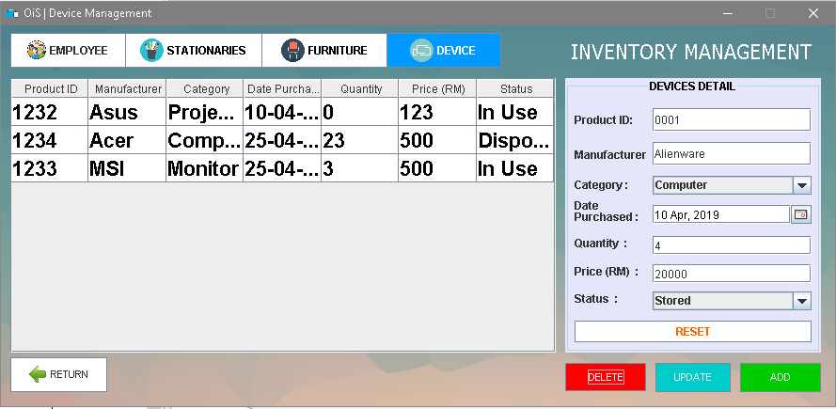

For delete device, user need to select from list on the table and then click delete button with red colour to delete device.

## Admin: Request list interface

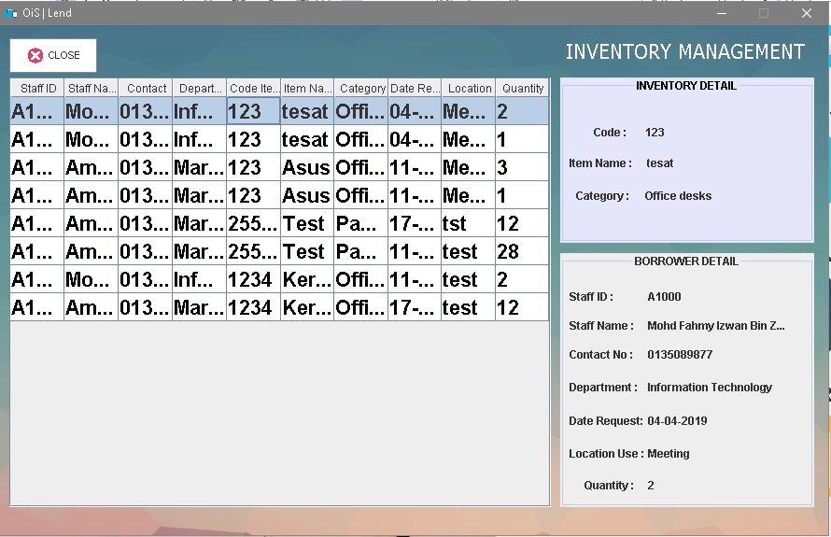

Base on image above show record list request interface from all inventory will open in new screen, so admin can know about other item to who, where, quantity, location and others.

## Admin: View report

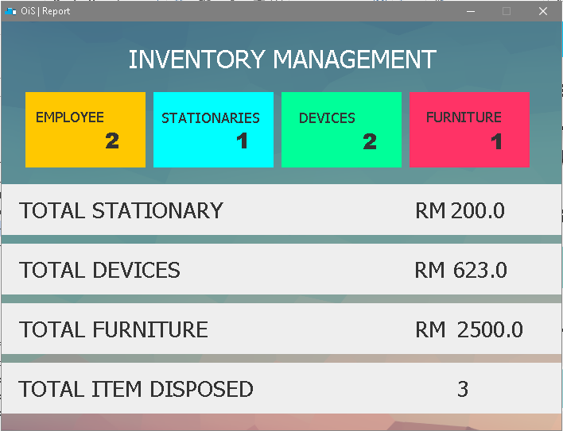

This is interface for admin to view report about all inventory. The yellow colour show staff, the blue colour show for stationaries, the green show for electronic devices, and red colour show for furniture that have been register. Next, total for stationary, devices, furniture will display total price and total item disposed quantity.

## 3.9 General Error Interface

## 3.9.1 Add Error Message

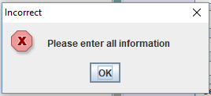

If user left empty place in any information, the error message will pop out to remind user to enter all information.

## 3.9.2 Update Error Message

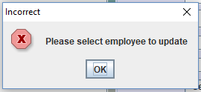

User need to select table which employee before they want to update because the error message will pop out if not select any employee detail from table at left side.

## 3.9.3 Delete Error Message

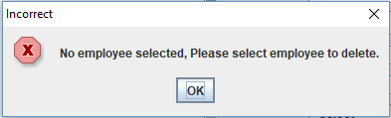

User need to select table which employee before they want to delete because the error message will pop out if not select any employee detail from table at left side.

## Staff: Stationaries Interface

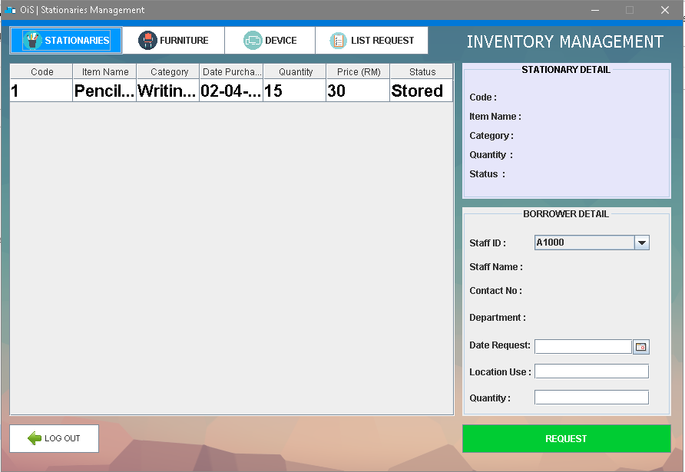

Stationaries interface have been set as default, so after staff login it will show this stationaries interface. Staff can view list from table what stationaries that can be request.

## 3.10.1 Request Stationaries

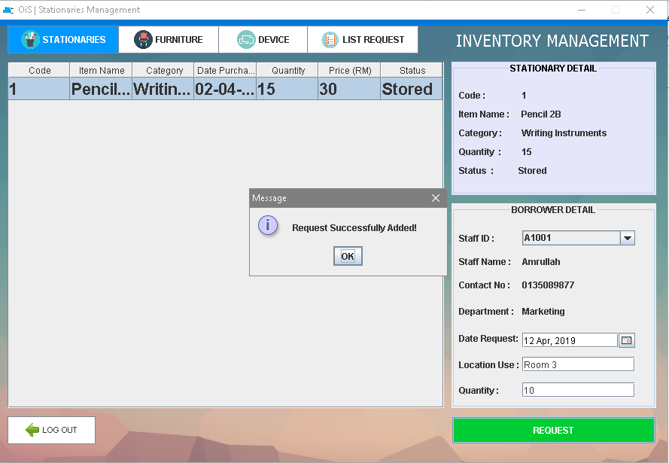

If staff want to make request, they need to select item that from table and then they need to select they staff ID from list, choose date request, location use and quantity that they want in borrower detail at right side. Then click button request that with green colour. The successful message will pop out.

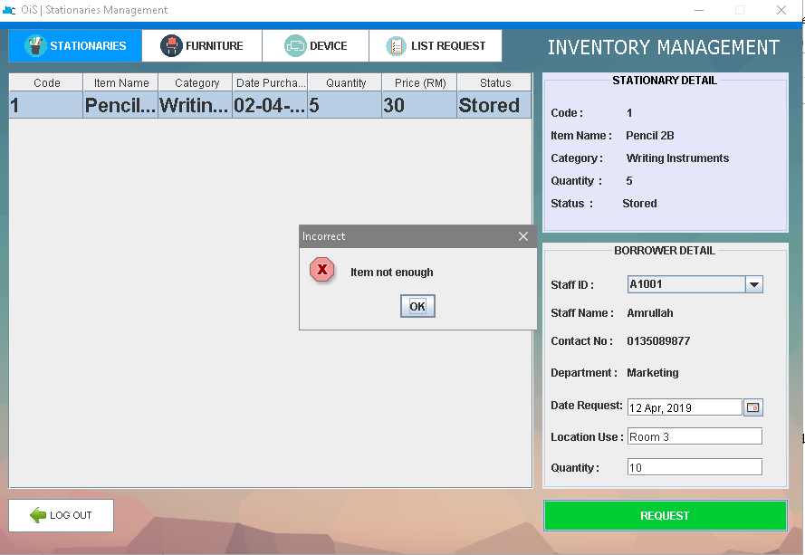

If staff request item that are more than quantity that available, the error message will pop out.

## Staff: Furniture Interface

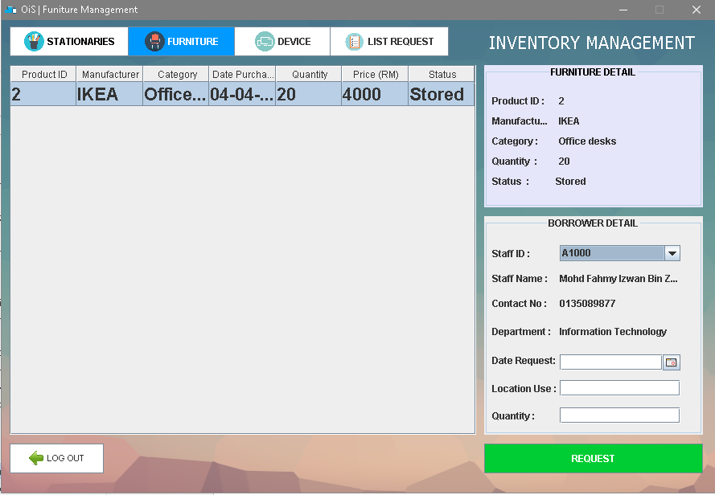

This interface for Furniture where staff can know what furniture that can be request.

## Staff: Device Interface

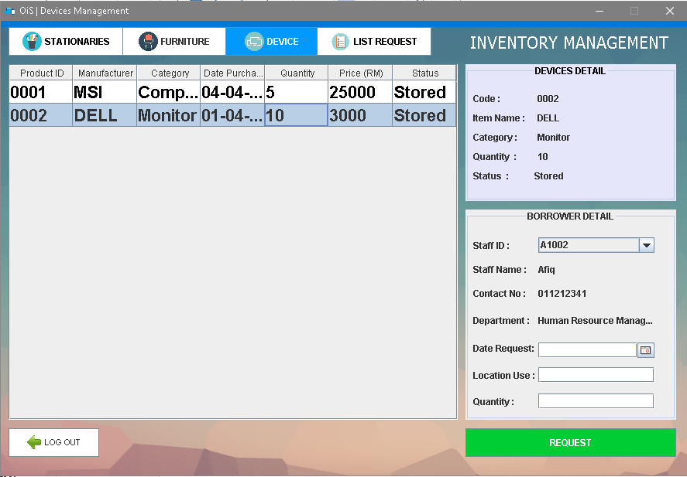

This is interface for Device where staff can know what Device that can be request base on list in table.

## Staff: List Request Interface

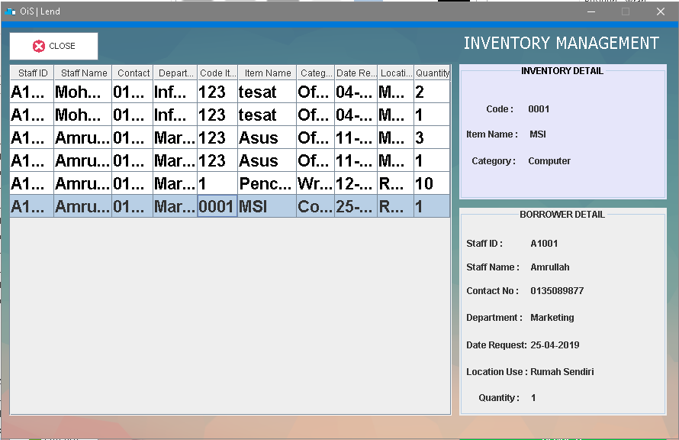

Based on image above show record list request interface from all inventory, so other staff can know about other item to who, where, quantity, location and others.

# 4.0 RESULT

**4.1 Problems encountered during project development**

Problems encountered during project development is crash of the Eclipse software because the hardware of laptop are low specification to develop this application. The second problem is time for development of application system are limited.

**4.2 Strength of the project**

Based on our inventory management system,our system be able to organize and manage register, update, delete either staff, furniture, stationaries and electronic device with effectively because we can track person who are responsible, quantity, location and know the status of inventory either in stored, in use and disposed. So user can know the current status of item either it can be request or not.

**4.3 Limitation of the project**

This application have some limitation which is the application cannot update and delete the data in bulk simultaneous. Data only can be delete or update one at a time according to the row that have been select.

# 5.0 CONCLUSION

As a conclusion our application system be able to reducing the burden to user when they use this application system because this system can help to track and manage inventories of office such as stationaries, furniture and electronic device. This application system also can record and store item detail such as item name, category, product code, date and others. Besides that user also can know the current status into three status like in use, in store and disposed and also the quantity of item that can be requested.

For future development, we hope it can be upgrade by improving our interface to more understanding and improve the system by adding feedback interface. So the other user can know comment or feedback about the item that have been lend from other user. We hope that our application system will help staff or employees doing better task in manage office inventory.